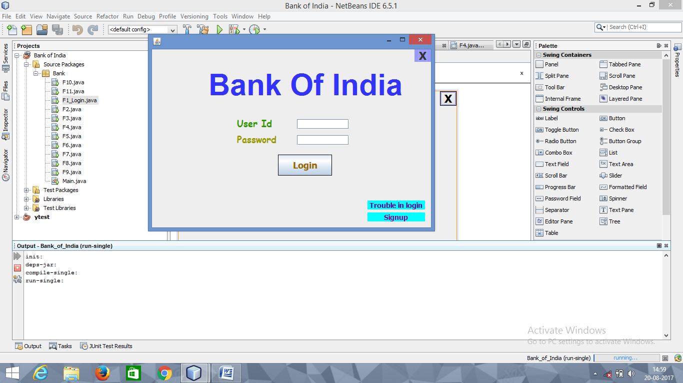

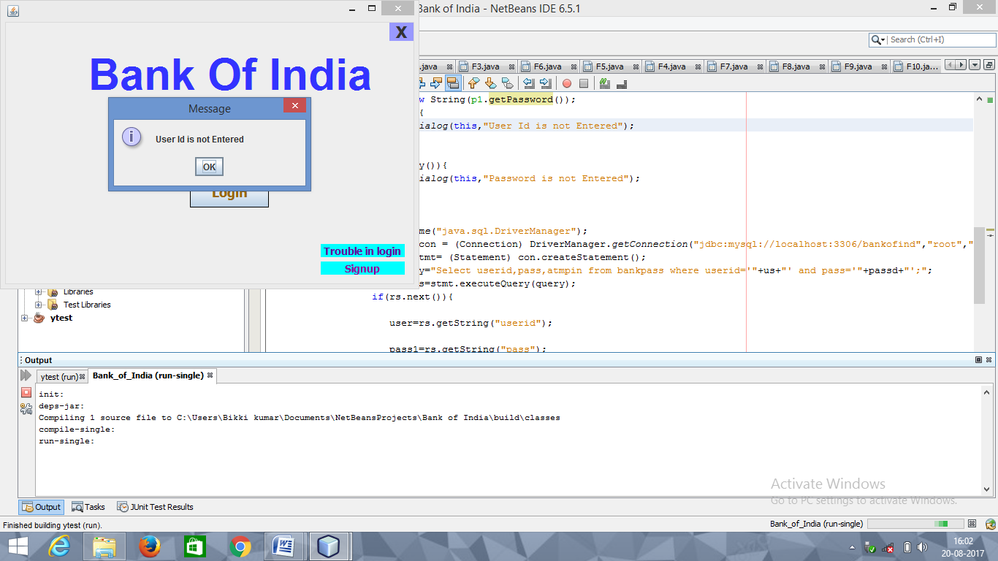

**FRAME-1**

**FOR LOGIN BUTTON**

String user=" ";

String pass1="";

int atm1=0;

String us=u1.getText();

String passd= new String(p1.getPassword());

if(us.isEmpty()){

op1.showMessageDialog(this,"User Id is not Entered");

}

if(passd.isEmpty()){

op1.showMessageDialog(this,"Password is not Entered");

}

else{

try{

Class.forName("java.sql.DriverManager");

Connection con = (Connection) DriverManager.getConnection("jdbc:mysql://localhost:3306/bankofind","root","root");

Statement stmt= (Statement) con.createStatement();

String query="Select userid,pass,atmpin from bankpass where userid='"+us+"' and pass='"+passd+"';";

ResultSet rs=stmt.executeQuery(query);

if(rs.next()){

user=rs.getString("userid");

pass1=rs.getString("pass");

atm1=Integer.parseInt(rs.getString("atmpin"));

}

if((us.equals(user))&&(passd.equals(pass1))){

op1.showMessageDialog(null,"WELCOME");

F4 f=new F4();

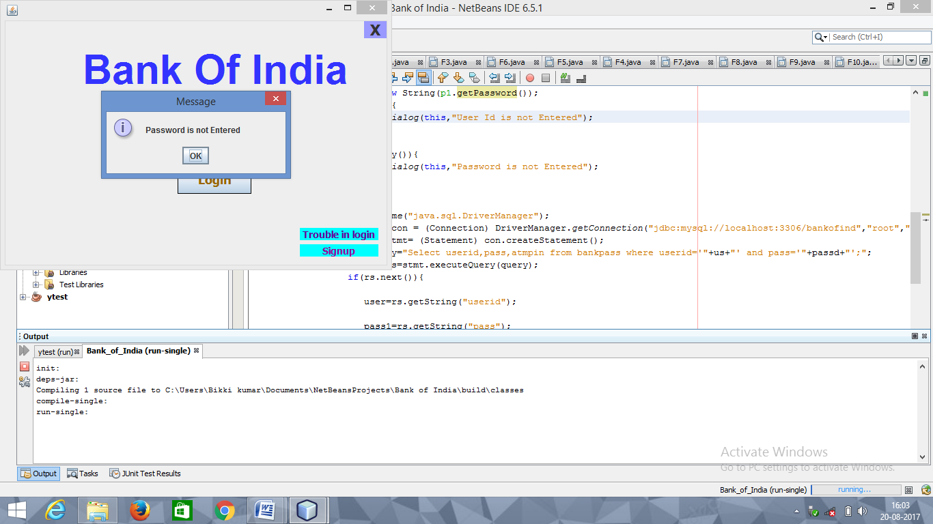

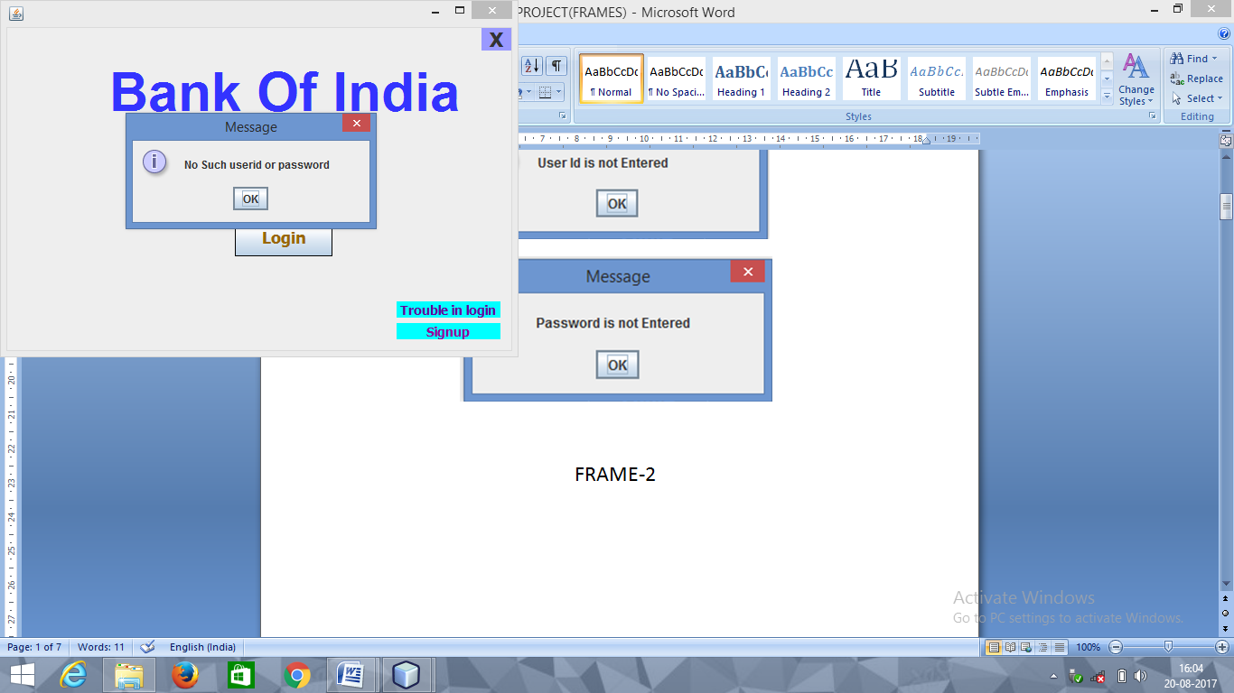

f.setVisible(true);

this.dispose();

}

else {

op1.showMessageDialog(null,"No Such userid or password ");

u1.setText("");

p1.setText("");

}

}

catch(Exception e)

{

op1.showMessageDialog(this,e.getMessage());

}

}

**FOR TROUBLE IN LOGIN**

F2 x=new F2();

x.setVisible(true);

this.dispose();

**FOR SIGNUP**

F3 f=new F3();

f.setVisible(true);

this.dispose();

**FOR [X]**

System.exit(0);

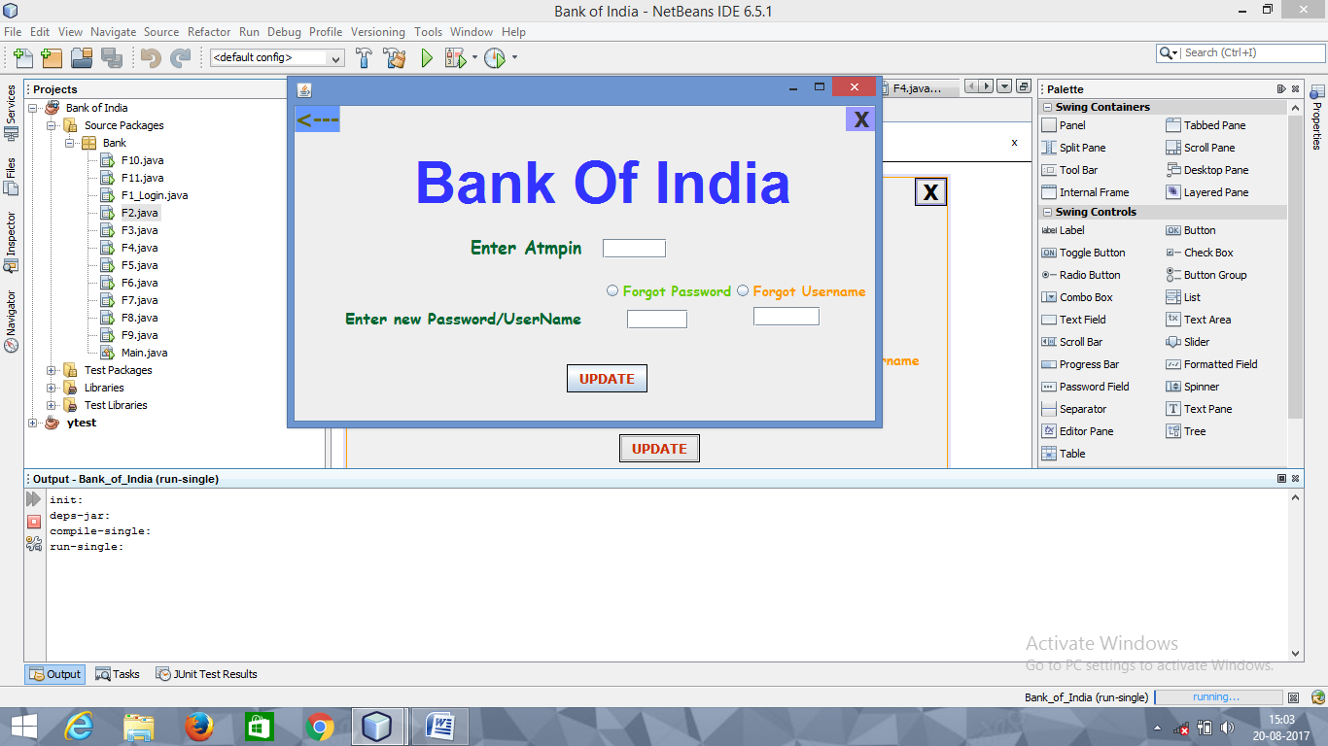

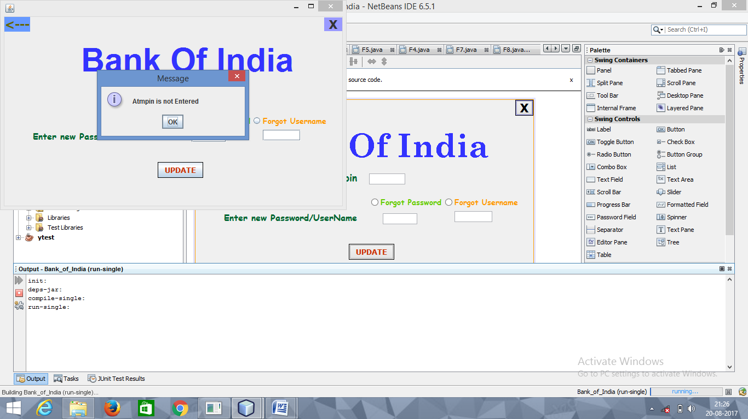

**FRAME-2**

**FOR UPDATE BUTTON**

String atmp=ap.getText();

if(atmp.isEmpty()){

op1.showMessageDialog(this,"Atmpin is not Entered");

}

else if(f1.isSelected()){

te3.setVisible(false);

te2.setVisible(true);

String pas=te2.getText();

try{

Class.forName("java.sql.DriverManager");

Connection con = (Connection) DriverManager.getConnection("jdbc:mysql://localhost:3306/bankofind","root","root");

Statement stmt= (Statement) con.createStatement();

String query="update bankpass set pass='"+pas+"'where atmpin='"+atmp+"';";

stmt.executeUpdate(query);

te2.setText("");

op1.showMessageDialog(null,"Password Sucessfully changed");

F1_Login r= new F1_Login();

r.setVisible(true);

this.dispose();

}

catch(Exception e)

{

op1.showMessageDialog(this,e.getMessage());

}

}

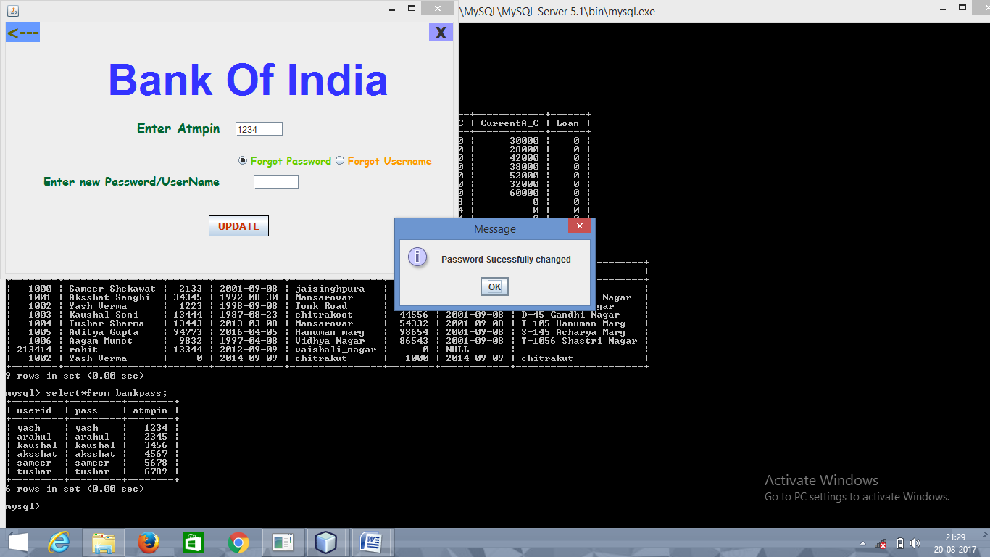

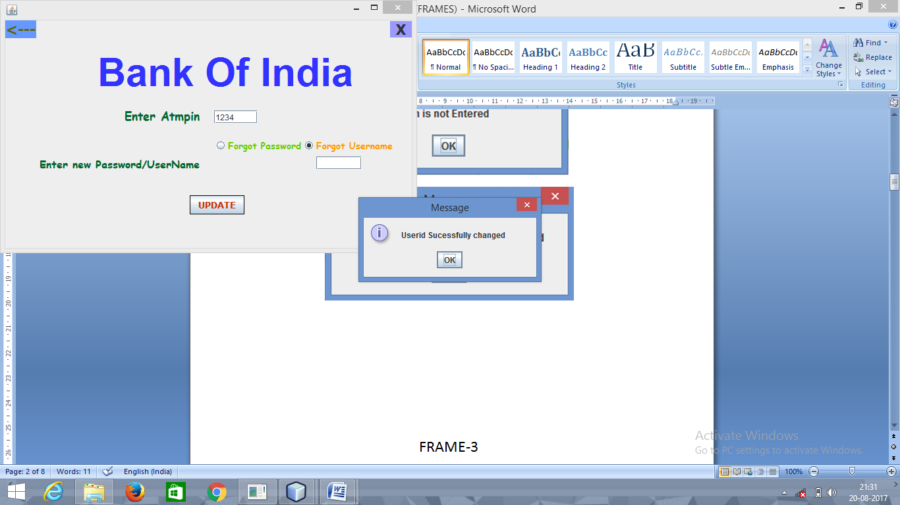

else if(f2.isSelected()){

te3.setVisible(true);

te2.setVisible(false);

String user=te3.getText();

try{

Class.forName("java.sql.DriverManager");

Connection con = (Connection) DriverManager.getConnection("jdbc:mysql://localhost:3306/bankofind","root","root");

Statement stmt= (Statement) con.createStatement();

String query="update bankpass set userid='"+user+"'where atmpin='"+atmp+"';";

stmt.executeUpdate(query);

te3.setText(" ");

op1.showMessageDialog(null,"Userid Sucessfully changed");

F1_Login r= new F1_Login();

r.setVisible(true);

this.dispose();

}

catch(Exception e)

{

op1.showMessageDialog(this,e.getMessage());

}

**FOR RADIO BUTTON –(Forgot Password)**

te3.setVisible(false);

te2.setVisible(true);

**FOR RADIO BUTTON –(Forgot Username)**

te2.setVisible(false);

te3.setVisible(true);

**FOR [🡨]**

F1_Login r= new F1_Login();

r.setVisible(true);

this.dispose();

**FOR [X]**

System.exit(0);

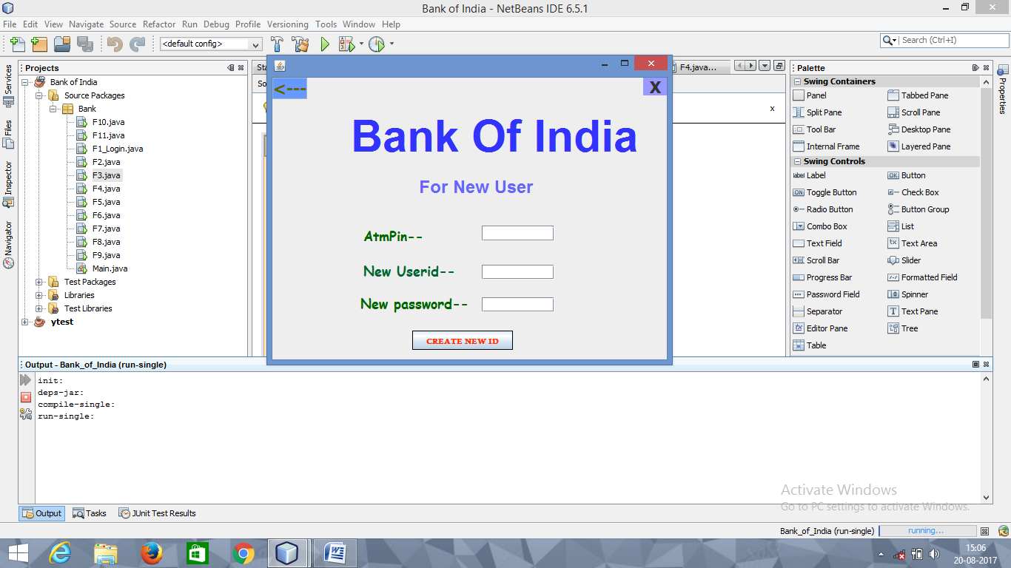

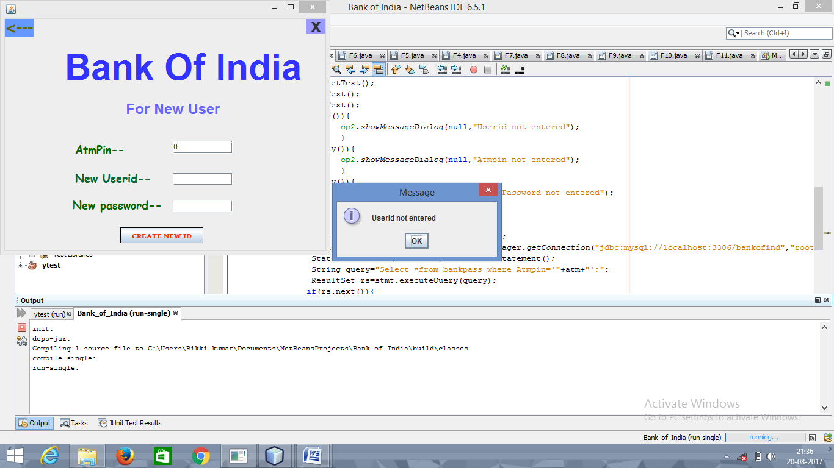

**FRAME-3**

**FOR CREATE NEW ID BUTTON**

String usrid =u1.getText();

String atm=a1.getText();

String pas=p1.getText();

if(usrid.isEmpty()){

op2.showMessageDialog(null,"Userid not entered");

}

else if(atm.isEmpty()){

op2.showMessageDialog(null,"Atmpin not entered");

}

else if(pas.isEmpty()){

op2.showMessageDialog(null," New Password not entered");

}

else{

try{

Class.forName("java.sql.DriverManager");

Connection con = (Connection) DriverManager.getConnection("jdbc:mysql://localhost:3306/bankofind","root","root");

Statement stmt= (Statement) con.createStatement();

String query="Select *from bankpass where Atmpin='"+atm+"';";

ResultSet rs=stmt.executeQuery(query);

if(rs.next()){

}

else{

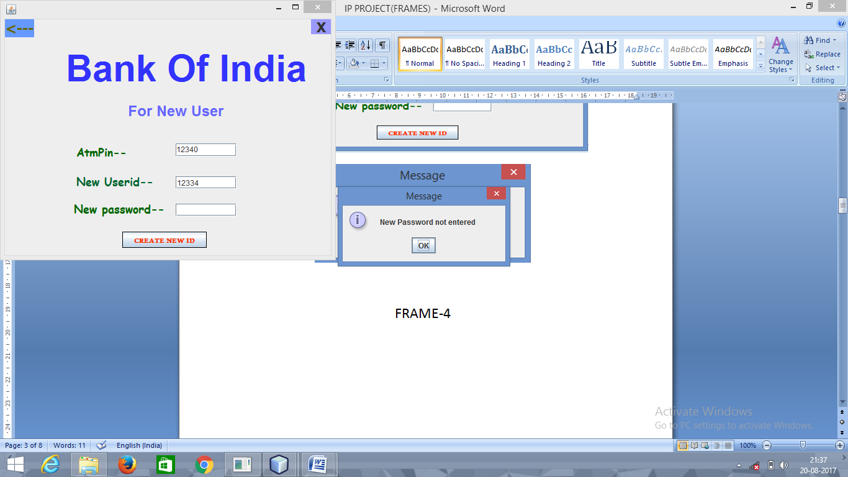

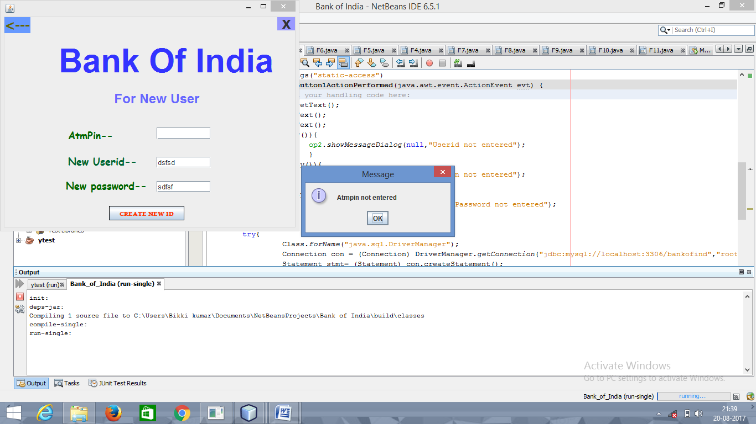

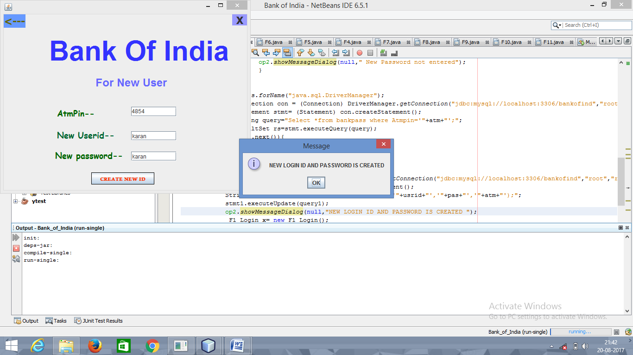

try{

Connection con1=(Connection) DriverManager.getConnection("jdbc:mysql://localhost:3306/bankofind","root","root");

Statement stmt1 =(Statement)con1.createStatement();

String query1="Insert into bankpass values('"+usrid+"','"+pas+"','"+atm+"');";

stmt1.executeUpdate(query1);

op2.showMessageDialog(null,"NEW LOGIN ID AND PASSWORD IS CREATED ");

F1_Login x= new F1_Login();

x.setVisible(true);

this.dispose();

}

catch(Exception e)

{

op2.showMessageDialog(this,e.getMessage());

}

}

}

catch(Exception e)

{

op2.showMessageDialog(this,e.getMessage());

}

}

**FOR [🡨]**

F1_Login r= new F1_Login();

r.setVisible(true);

this.dispose();

**FOR [X]**

System.exit(0);

**FRAME-4**

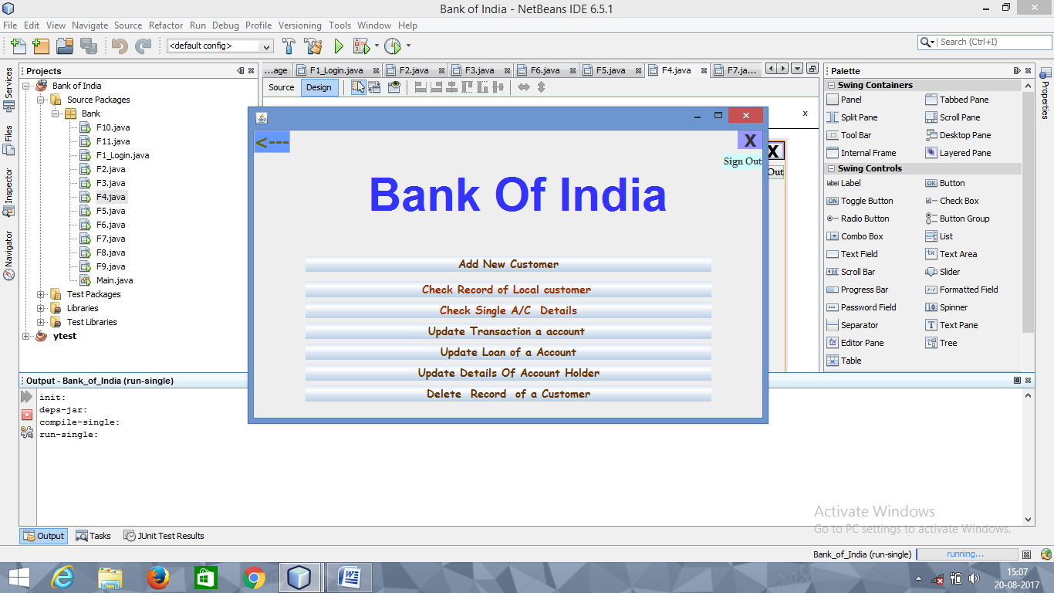

**FOR ADD NEW CUSTOMER BUTTOM**

F7 f=new F7();

f.setVisible(true);

this.dispose();

**FOR CHECK RECORD OF LOCAL CUSTOMER BUTTON**

F5 f=new F5();

f.setVisible(true);

this.dispose();

**FOR CHECK SINGLE A/C DETAIL BUTTON**

F6 f=new F6();

f.setVisible(true);

this.dispose();

**FOR UPDATE TRANSACTION OF A ACCOUNT BUTTON**

F8 x=new F8();

x.setVisible(true);

this.dispose();

**FOR LOAN OF A ACCOUNT BUTTON**

F10 x=new F10();

x.setVisible(true);

this.dispose();

**FOR UPDATE DETAIL OF A ACCOUNT HOLDER BUTTON**

F11 a=new F11();

a.setVisible(true);

this.dispose();

**FOR DELETE RECORD OF A CUSTOMER BUTTON**

F9 a=new F9();

a.setVisible(true);

this.dispose();

**FOR SIGNOUT**

F1_Login r= new F1_Login();

r.setVisible(true);

this.dispose();

**FOR [🡨]**

F1_Login r= new F1_Login();

r.setVisible(true);

this.dispose();

**FOR [X]**

System.exit(0);

**FRAME-5**

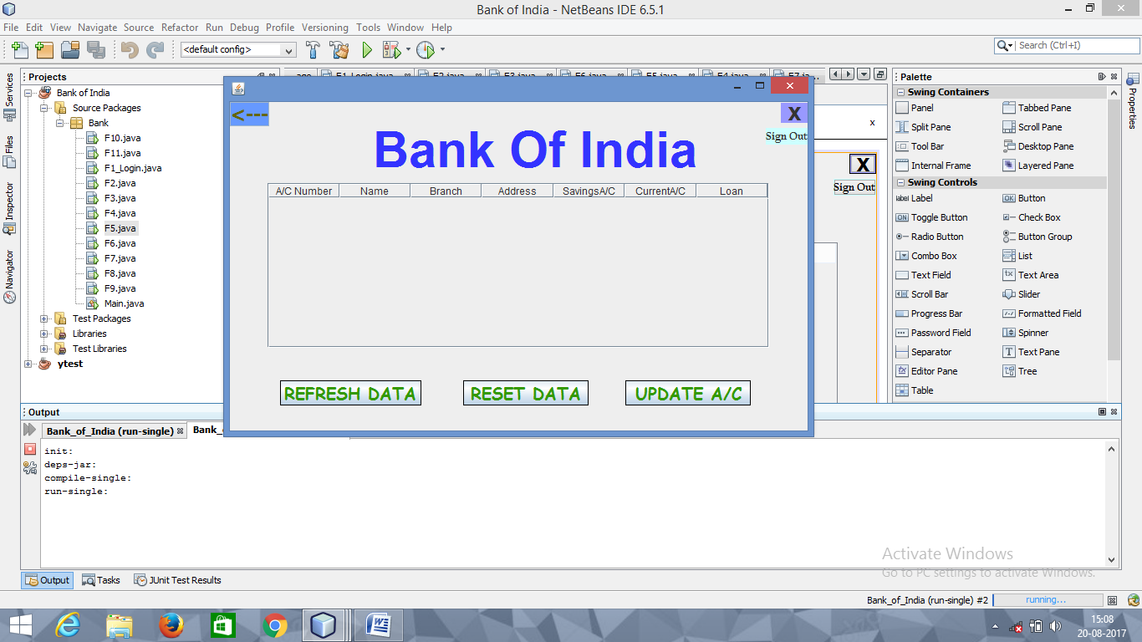

**FOR REFRESH DATA BUTTON**

DefaultTableModel model= (DefaultTableModel)

jTable1.getModel();

try{

Class.forName("java.sql.DriverManager");

Connection con = (Connection) DriverManager.getConnection("jdbc:mysql://localhost:3306/bankofind","root","root");

Statement stmt= (Statement) con.createStatement();

String query="Select*from Bankdata;";

ResultSet rs=stmt.executeQuery(query);

while(rs.next()){

String Acc_no=rs.getString("Acc_no");

String Name=rs.getString("Name");

String Branch=rs.getString("Branch");

String Address=rs.getString("Address");

String SavingA_C=rs.getString("SavingsA_C");

String CurrentA_C=rs.getString("CurrentA_C");

String Loan=rs.getString("Loan");

model.addRow (new Object[] {Acc_no,Name,Branch,Address,SavingA_C,CurrentA_C,Loan});

}

}

catch(Exception e)

{

op1.showMessageDialog(this,e.getMessage());

}

**FOR RESET A/C BUTTON**

DefaultTableModel model=(DefaultTableModel)

jTable1.getModel();

int rows=model.getRowCount();

if(rows>0){

{

for(int i=0; i<rows;i++)

model.removeRow(0);

}

}

**FOR UPDATE A/C BUTTON**

F8 x=new F8();

x.setVisible(true);

this.dispose();

**FOR SIGNOUT**

F1_Login r= new F1_Login();

r.setVisible(true);

this.dispose();

**FOR [🡨]**

F4 r= new F4();

r.setVisible(true);

this.dispose();

**FOR [X]**

System.exit(0);

**FRAME-6**

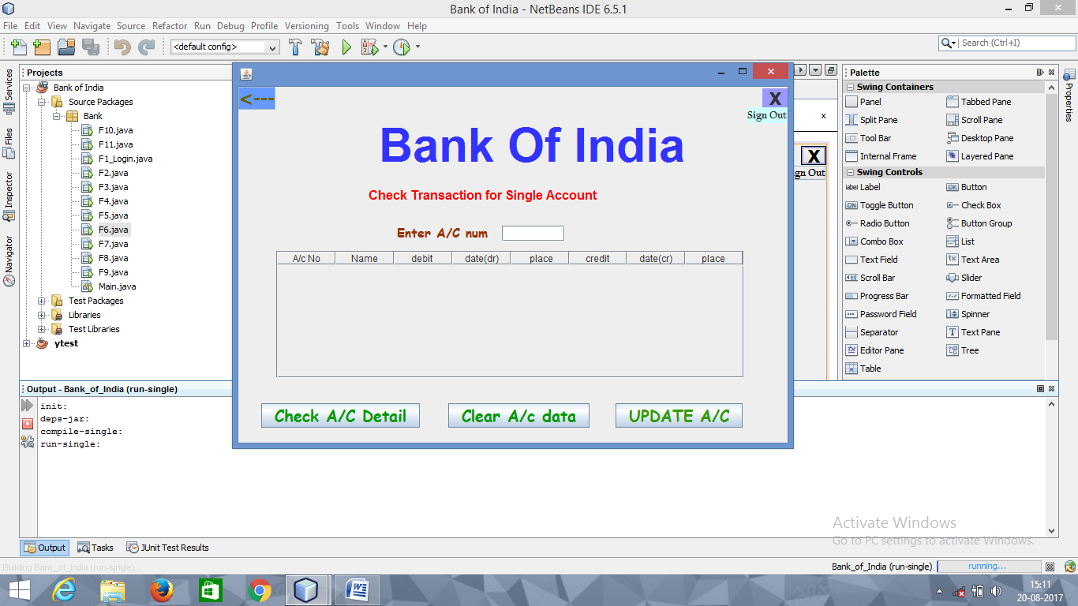

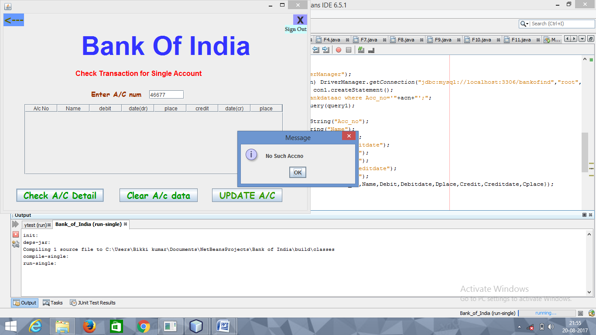

**FOR CHECK A/C DETAIL BUTTON**

String acn=ac.getText();

DefaultTableModel model= (DefaultTableModel)

jTable1.getModel();

try{

Class.forName("java.sql.DriverManager");

Connection con = (Connection) DriverManager.getConnection("jdbc:mysql://localhost:3306/bankofind","root","root");

Statement stmt= (Statement) con.createStatement();

String query="Select *from bankdata where Acc_no='"+acn+"';";

ResultSet rs=stmt.executeQuery(query);

if(rs.next()){

try{

Class.forName("java.sql.DriverManager");

Connection con1 = (Connection) DriverManager.getConnection("jdbc:mysql://localhost:3306/bankofind","root","root");

Statement stmt1= (Statement) con1.createStatement();

String query1="Select*from bankdataac where Acc_no='"+acn+"';";

ResultSet rs1=stmt1.executeQuery(query1);

while(rs1.next()){

String Acc_no=rs.getString("Acc_no");

String Name=rs.getString("Name");

String Debit=rs.getString("Debit");

String Debitdate=rs.getString("Debitdate");

String Dplace=rs.getString("DPlace");

String Credit=rs.getString("credit");

String Creditdate=rs.getString("creditdate");

String Cplace=rs.getString("CPlace");

model.addRow (new Object[] {Acc_no,Name,Debit,Debitdate,Dplace,Credit,Creditdate,Cplace});

}

}

catch(Exception e)

{

op1.showMessageDialog(this,e.getMessage());

}

}

else{

op1.showMessageDialog(null,"No Such Accno");

}

}

catch(Exception e)

{

op1.showMessageDialog(this,e.getMessage());

}

**FOR CLEAR A/C DATA BUTTON**

DefaultTableModel model=(DefaultTableModel)

jTable1.getModel();

int rows=model.getRowCount();

if(rows>0){

{

for(int i=0; i<rows;i++)

model.removeRow(0);

}

**FOR UPDATE A/C BUTTON**

F8 x=new F8();

x.setVisible(true);

this.dispose();

**FOR SIGNOUT**

F1_Login r= new F1_Login();

r.setVisible(true);

this.dispose();

**FOR [🡨]**

F4 r= new F4();

r.setVisible(true);

this.dispose();

**FOR [X]**

System.exit(0);

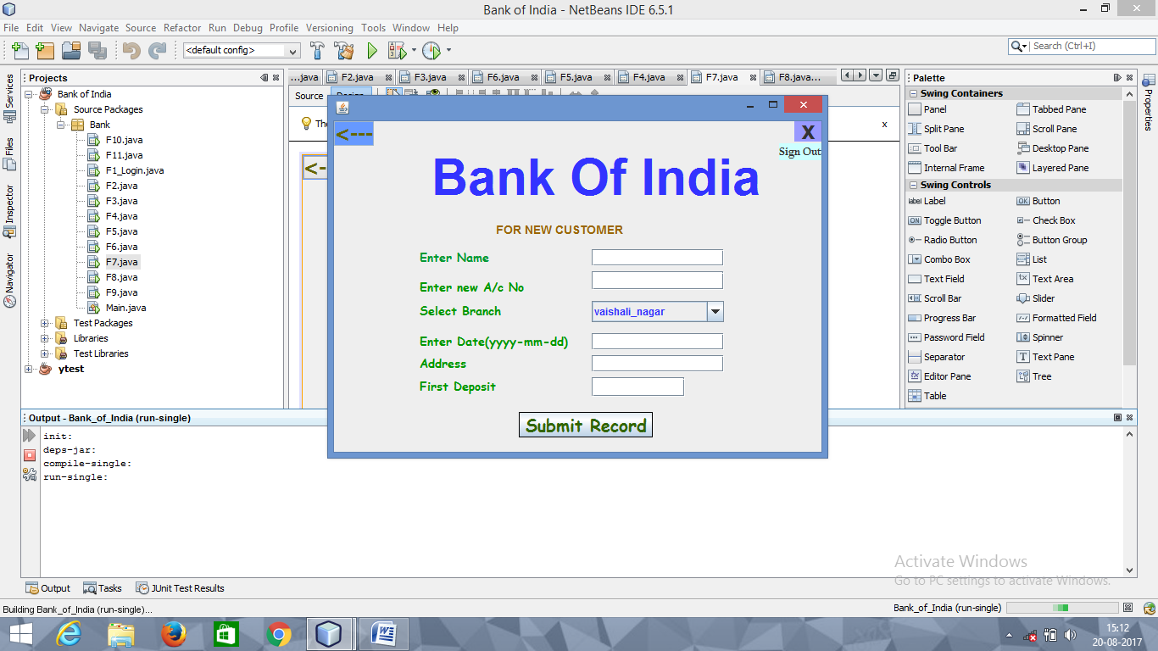

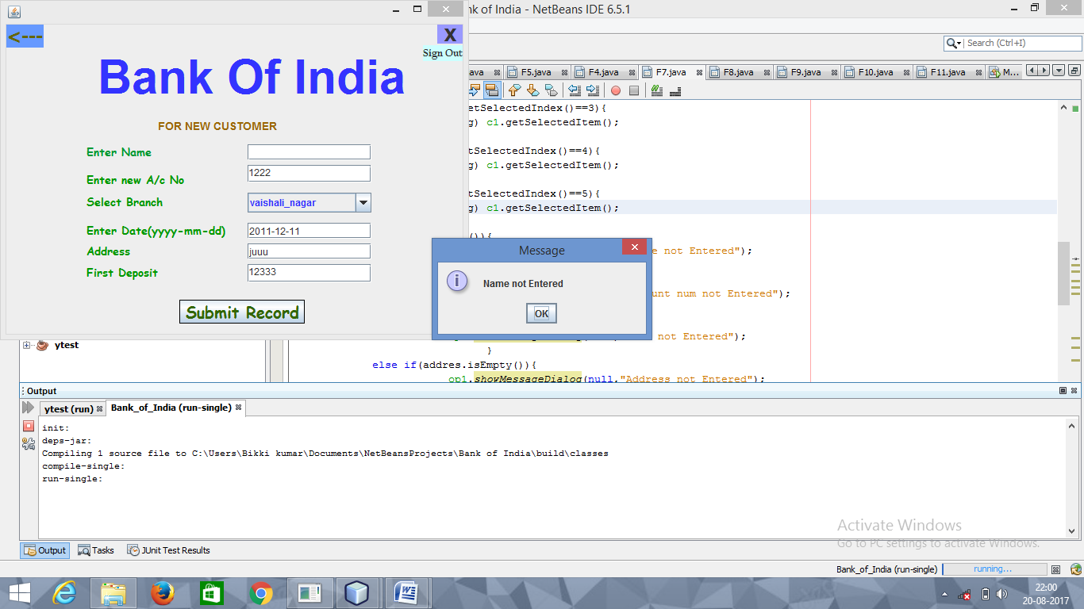

**FRAME-7**

**FOR SUBMIT RECORD BUTTON**

String name=nm.getText();

String acno=acn.getText();

String date=d1.getText();

String addres=add.getText();

String first=fd.getText();

String current="0";

String loan="0";

String cplace="";

String cdate="null";

String br="";

if(c1.getSelectedIndex()==0){

br=(String) c1.getSelectedItem();

}

if(c1.getSelectedIndex()==1){

br=(String) c1.getSelectedItem();

}

if(c1.getSelectedIndex()==2){

br=(String) c1.getSelectedItem();

}

if(c1.getSelectedIndex()==3){

br=(String) c1.getSelectedItem();

}

if(c1.getSelectedIndex()==4){

br=(String) c1.getSelectedItem();

}

if(c1.getSelectedIndex()==5){

br=(String) c1.getSelectedItem();

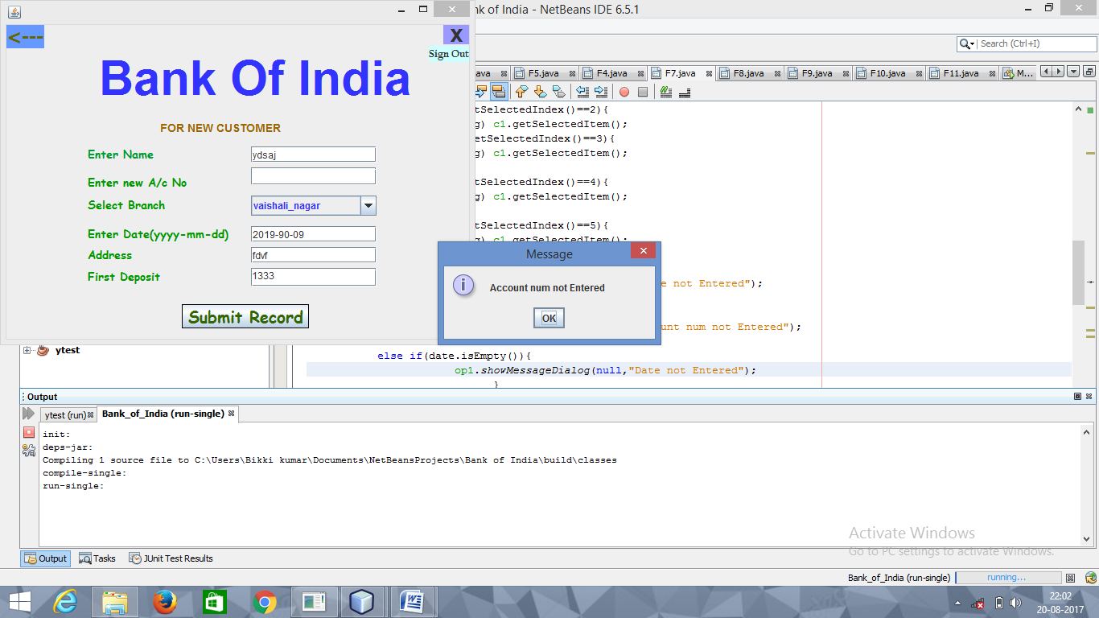

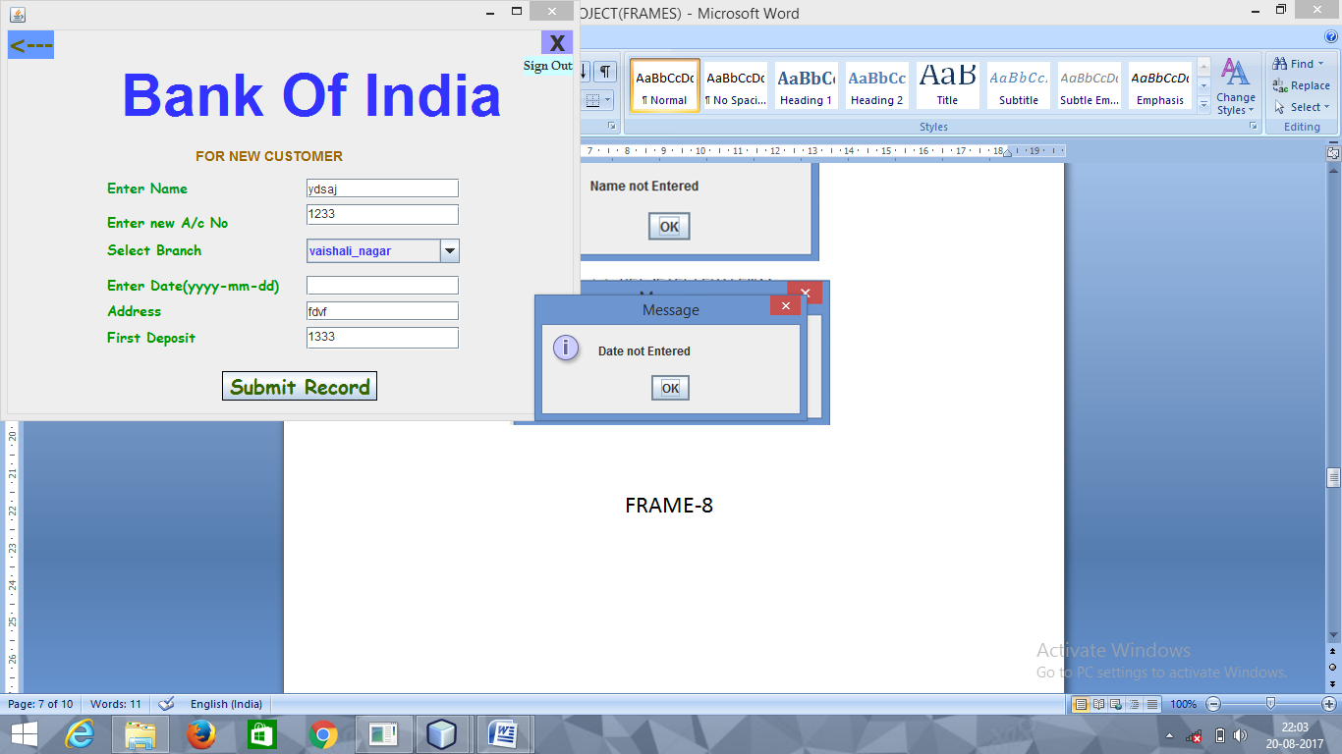

}

if(name.isEmpty()){

op1.showMessageDialog(null,"Name not Entered");

}

else if(acno.isEmpty()){

op1.showMessageDialog(null,"Account num not Entered");

}

else if(date.isEmpty()){

op1.showMessageDialog(null,"Date not Entered");

}

else if(addres.isEmpty()){

op1.showMessageDialog(null,"Address not Entered");

}

else if(first.isEmpty()){

op1.showMessageDialog(null,"First deposit not Entered");

}

else{

try{

Class.forName("java.sql.DriverManager");

Connection con = (Connection) DriverManager.getConnection("jdbc:mysql://localhost:3306/bankofind","root","root");

Statement stmt= (Statement) con.createStatement();

String query="Select*from Bankdata where Acc_no='"+acno+"';";

ResultSet rs=stmt.executeQuery(query);

if(rs.next()){

}

else{

try{

Class.forName("java.sql.DriverManager");

Connection con2 = (Connection) DriverManager.getConnection("jdbc:mysql://localhost:3306/bankofind","root","root");

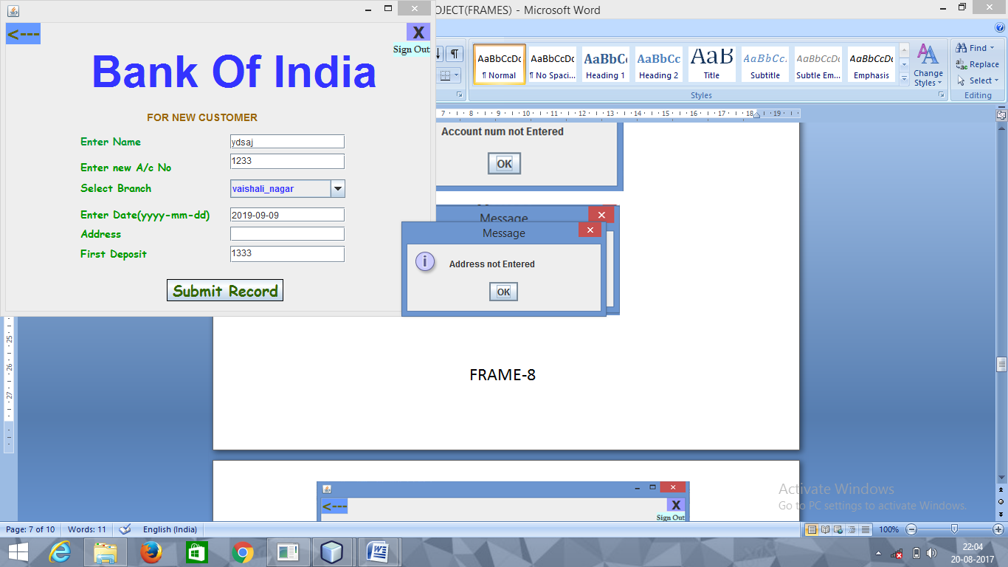

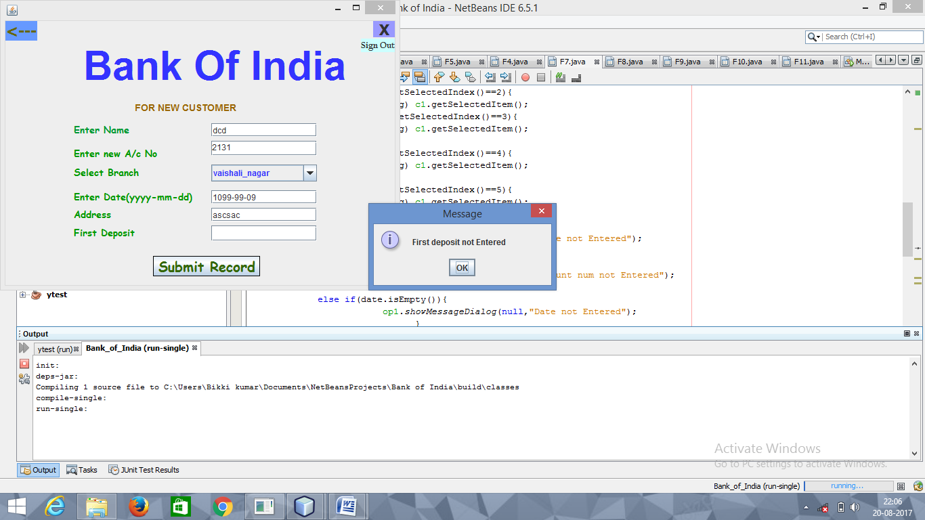

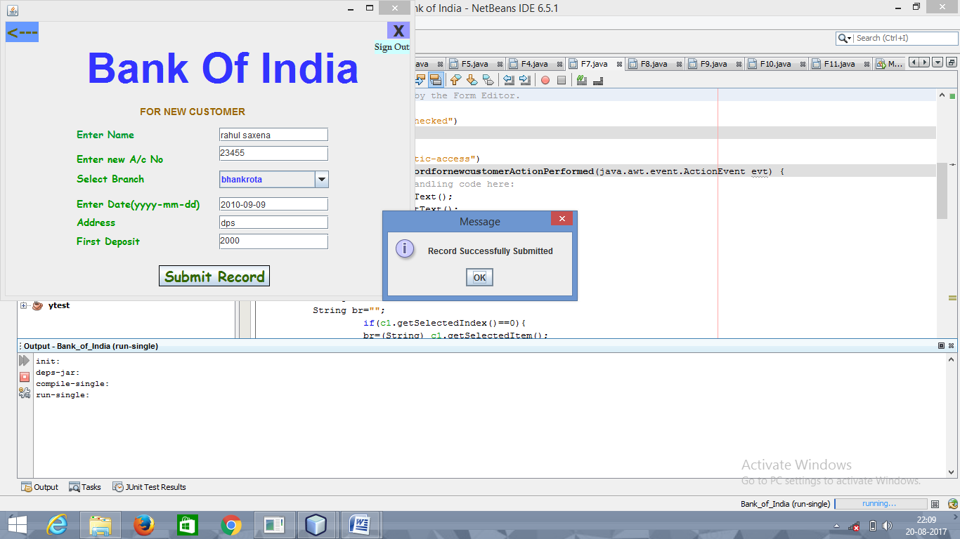

Statement stmt2= (Statement) con2.createStatement();

String query2="Insert into Bankdata values('"+acno+"','"+name+"','"+br+"','"+addres+"','"+first+"','"+current+"','"+loan+"');";

stmt2.executeUpdate(query2);

Statement stmt1= (Statement) con.createStatement();

String query1="Insert into Bankdataac values('"+acno+"','"+name+"','"+first+"','"+date+"','"+br+"','"+current+"',"+cdate+",'"+cplace+"');";

stmt1.executeUpdate(query1);

op1.showMessageDialog(null,"Record Successfully Submitted");

}

catch(Exception e)

{

op1.showMessageDialog(this,e.getMessage());

}

}

}

catch(Exception e)

{

op1.showMessageDialog(this,e.getMessage());

}

**FOR SIGNOUT**

F1_Login r= new F1_Login();

r.setVisible(true);

this.dispose();

**FOR [🡨]**

F4 r= new F4();

r.setVisible(true);

this.dispose();

**FOR [X]**

System.exit(0);

